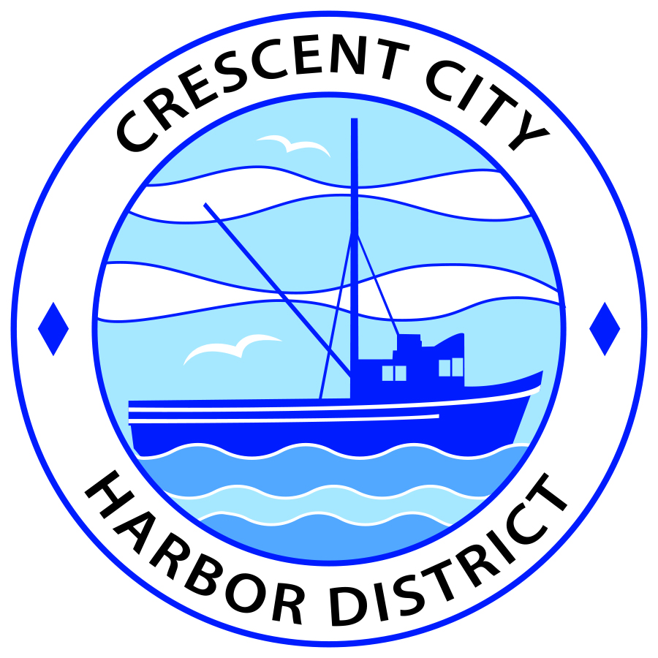

SPECIAL MEETING AGENDA
CRESCENT CITY HARBOR PUBLIC FINANCING CORPORATON
A California Nonprofit Public Benefit Corporation

At the Crescent City Harbor District Office meeting room
101 Citizens’ Dock Road, Crescent City, California 95531

Special Meeting Tuesday, January 22, 2019 5:15 P.M.

- Call to Order/Roll Call

- Public Comment

- Election of Officers for 2019

- Approval of the Meeting Notes from the 2018 Special Meeting

- Board of Directors comments

Adjournment
*** Adjournment to the Special Meeting of the Crescent City Harbor Public Financing Corporation, A California Nonprofit Public Benefit Corporation, meeting scheduled for Tuesday, January 7, 2020 at 5:15 P.M. at the Harbor District Office, 101 Citizens’ Dock Road, Crescent City, California.

